ZHOU Kevin
Student ID : A0197122H
NUS - IE5101 - Applied Forecasting Methods
Project 1


Table of Contents
2.1 Step 1: Simple Regression Model 2
2.1.1 model proposed 2
2.1.2 Results Analysis 3
2.1.2 model Checking and Diagnosis 3
Outliers 5
Collinearity 5
2.2 Full Regression Model 8
2.2.1 Full Run 8
2.2.1 Greedy search 8
Normality check based on the residuals 13
Y-axis Unbalanced 14
Heteroscedasticity 14
Nonlinear 16
Outliers 16
Large Y-axis Datapoints 17
X-axis Unbalanced 17

2.1 Step 1: Simple Regression Model

2.1.1 model proposed
For the first simple regression, we will try to have a simple interpretable model. To ease the interpretation :
1- We will opt only for 5 variables
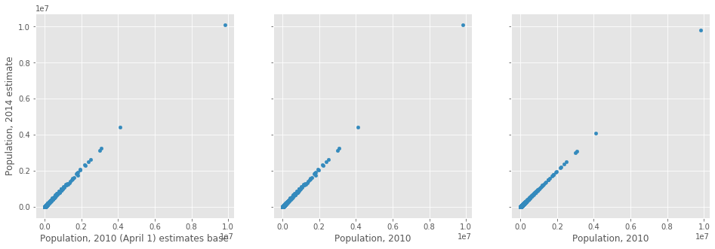
Illustration 1: Correlation between the different Population variables
2- The variable chosen should be as much non collinear as possible. We can easily suspect some level of collinearity between variables of the same category such as :
- race related variables (“White alone, percent, 2014”, “Black or African American alone, percent, 2014”, “White alone, not Hispanic or Latino, percent”, “Black-owned firms, percent, 2007”…)
- population number related variables,
- or wealthiness related variables…
This is particularly true for the population number across the years in the 3 scatter plots below where we observe a nearly perfect identity function when plotting against each other.
3- We choose the variables one by one with the maximum R squared value to have for the maximum explained variance (a simple linear regression with the variable). This is however just a simplification and would surely not yield the most accurate results.

With the below 3 criteria: our model will use the following 5 features, as they will represent respectively, age, gender, race, education level and wealthiness of the county and have a level of non collinearity mutually.
1 | Q("Persons 65 years and over, percent, 2014") | 'AGE775214'
2 | Q("Female persons, percent, 2014") | 'SEX255214'
3 | Q("Black or African American alone, percent, 2014") | 'RHI225214'
4 | Q("High school graduate or higher, percent of persons age 25+, 2009-2013") | 'EDU635213'
5 | Q("Persons below poverty level, percent, 2009-2013") | ‘PVY020213'

2.1.2 Results Analysis
The OLS regression with the 5 variables above and a intercept value gives the following results.
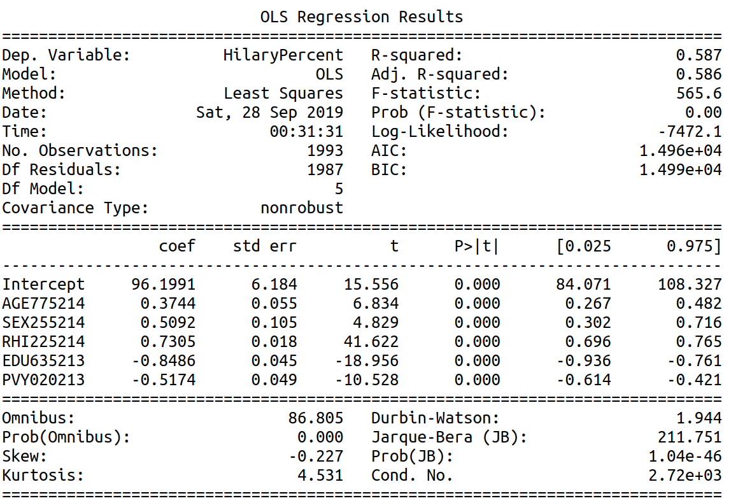
Illustration 2: OLS Regression results with training set (train-test split of 80% and 20%)
With 5 variables, the R-squared indicates that 58.7 % of the variation are explained by this model containing 5 variables.
All the variables’ p-value are close to zero and their associated t-score big meaning that they all are relevant in the model.
The big value of the F-statistic also goes along that way.

2.1.2 model Checking and Diagnosis
We will mainly check the validity of the below assumptions made by the ordinary least squared regression:
- Normality assumptions checks based on residuals
- Uncorrelated predictors assumptions
- Homoscedasticity assumption i.e. the constant variance is the predictors and the dependent variable.
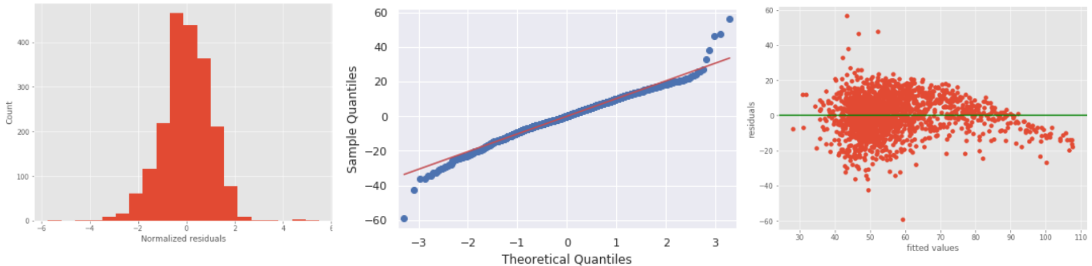
Illustration 3: (from left to right) histogram of normalized residuals, qq plot of the residuals, scatter plot of the residuals against the fitted values
The quantile-quantile plot of the residuals shows a rather close fit to the normal distribution in the middle. The histogram plot also display a pretty good normally distributed values of residuals.
However in the upper and lower tails, we notice departure from the fitted normal line making it a long-tail distribution. Either data does not satisfy normal assumption or the model is not sufficient enough to describe the dependent variable.

The scatter plot of the residuals against the fitted values shows more clearly some curving and also a slight non-constant variance in the distribution of residuals with smaller variance on higher end of fitted values. The homoscedasticity and normality assumptions seem not to be respected.

The partial plots of residuals against the 4 predictors ('AGE775214', 'SEX255214', 'EDU635213', 'PVY020213') don’t show any particular violation of assumptions.

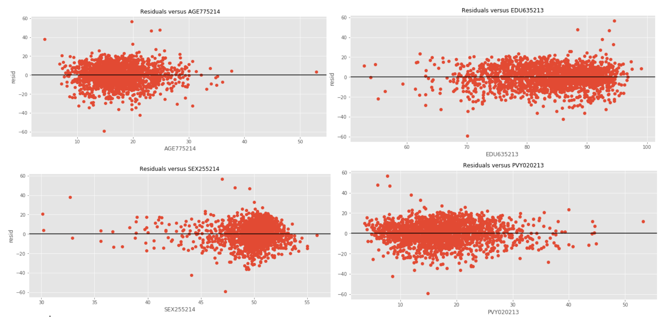
Illustration 4: Partial plots of residuals vs predictors : 'AGE775214', 'SEX255214', 'EDU635213', 'PVY020213'
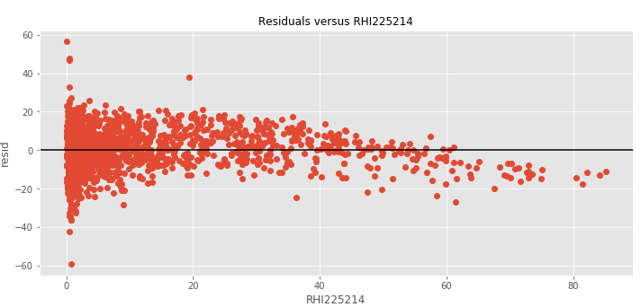
Illustration 5: Partial plots of residuals vs predictors ‘RHI225214’
The partial plot of residuals against predictor ‘RHI225214’ shows however some clear curvature.

We can apply a square root transformation to the predictor which is easier than the log transformation since the predictor variable contains values equal to 0.

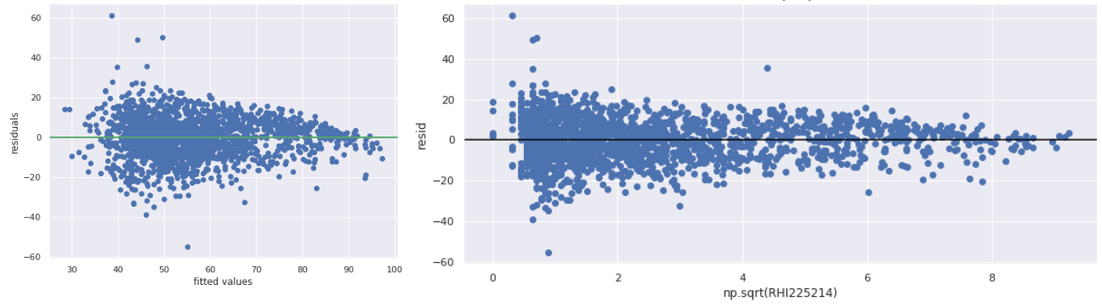
Illustration 6: the residuals plot against fitted values and against the predictor
The model with the square root of RHI225214 instead of RHI225214 has indeed removed the curvature from both the residuals plot against fitted values and against the predictor. This is due to the non linearity of the predictor as shown in the scatter plot.
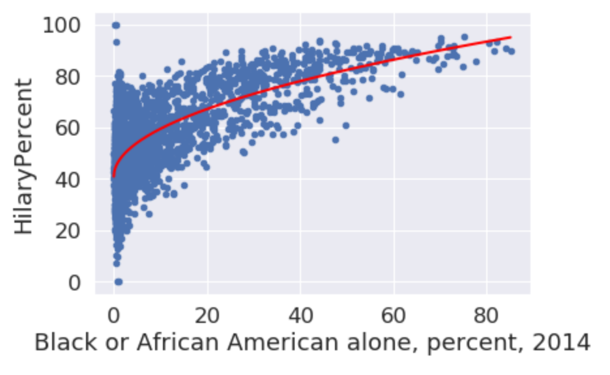
Illustration 7: Scatter plot of HilaryPercent against RHI225214
The variance explained has been improved to R²=60.1%. However we still observe the non constant-variance of the residuals as variance of residuals tends to decrease when the predictor increases.

Outliers
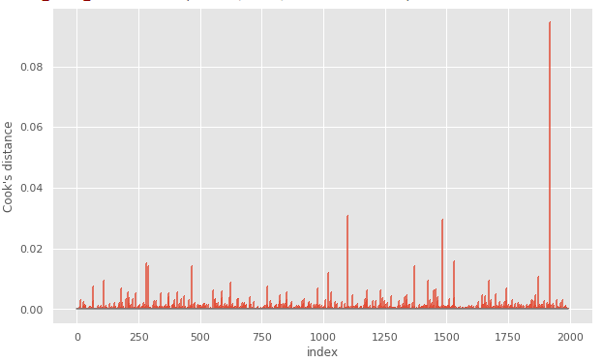
Assessing the magnitudes of the Cook's distance of the observations does not yield any particular results. Based on this There are no points with high enough values to be considered to be a possible problem (all distance are inferior to 0.1)

The influence plots gives however points that may need our attentions. There are quite a number of low leverage influential points that may distort our regression model in the blue rectangles below.
We can also distinguish some high leverage and high influential points that may cause even more issues displayed below in green rectangles.
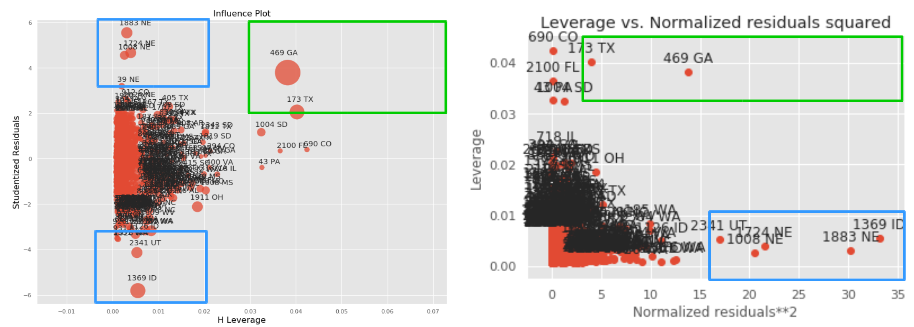
Those points have typically low number of population. In the next model we will build, we may want to include the number of population/voters in our model.

Collinearity
Let’s now consider the collinearity level between the predictors of our model
By computing the correlation coefficient, we still notice some minor collinearity between 4 and 5 (corr =-0.65) and 3 and 5 (corr =0.44).
For 4, we have taken a square root transformation since it fitted better the curve of feature clearly not linear in the upper value range.

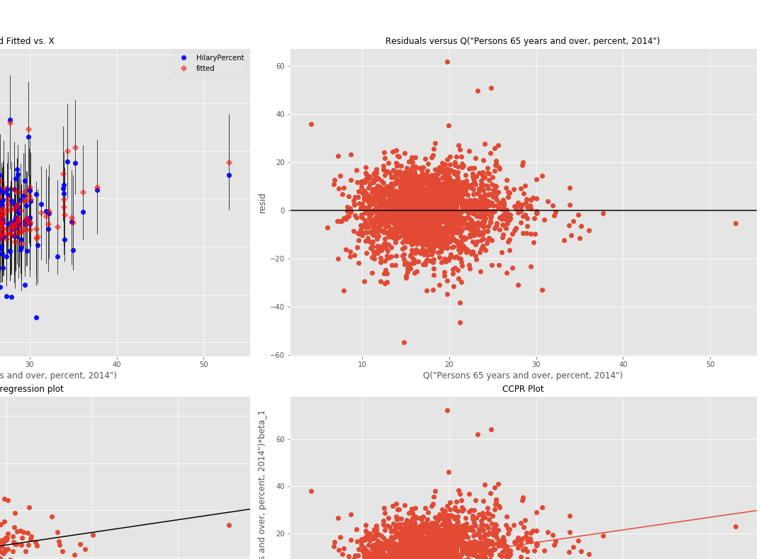
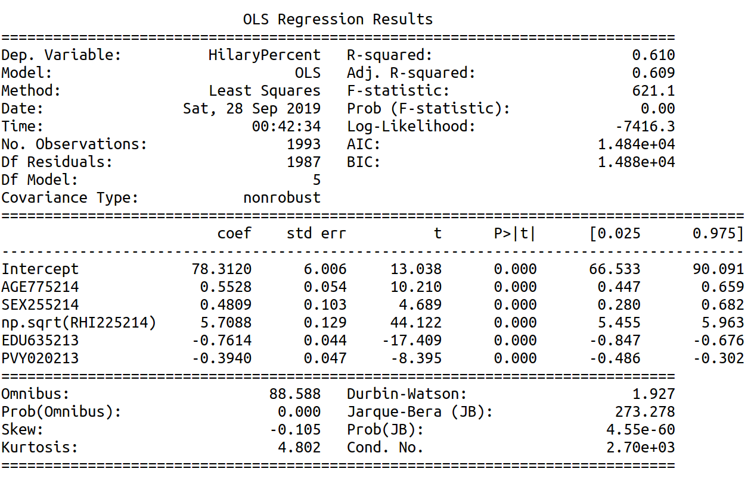
Illustration 8: OLS Regression results with the square root of ‘RHI225214’, with training set (train-test split of 80% and 20%)
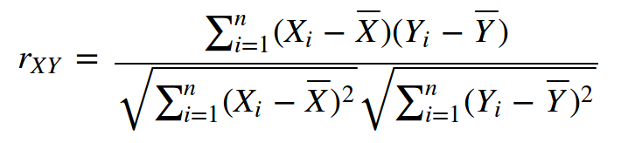

Applying a log transformation makes it only slightly better.

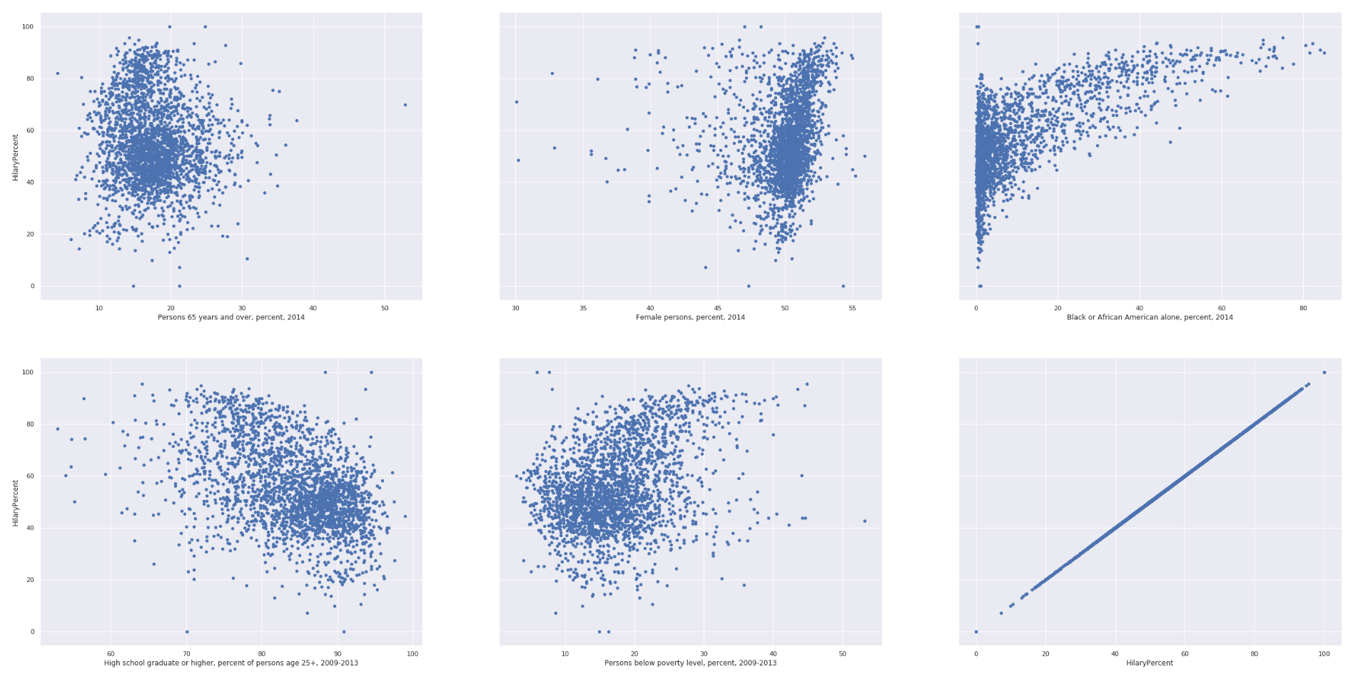
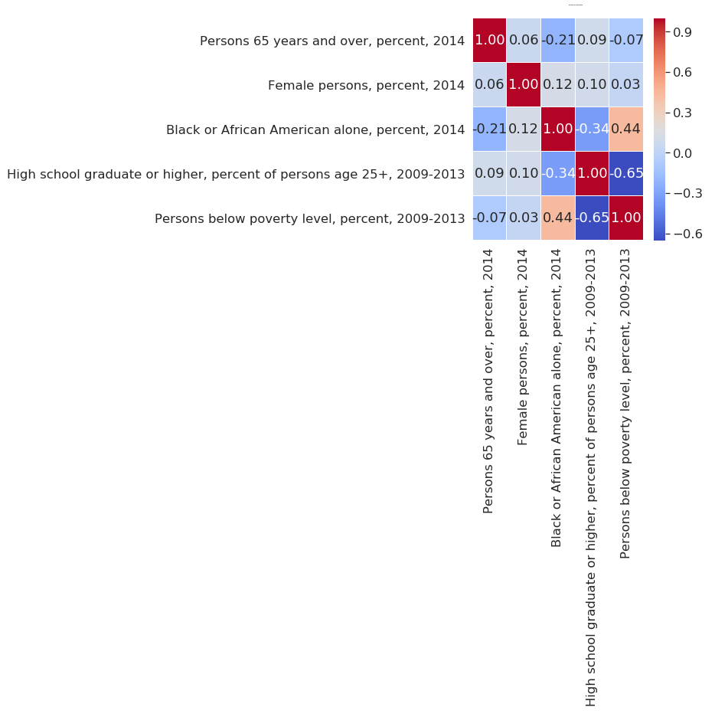
The R² square is low : lots of variance is not explained by the variables chosen.

2.2 Full Regression Model
The metrics used to evaluate the model will be the weighted mean squared errors WMSE.

2.2.1 Full Run
A run of every combination of features (52 features in total) would be computationally too costly to execute. We would have to fit the linear regression n times with n ==
My computer computes roughly R=10 linear regressions per seconds. It would have taken n/R= to perform the full run. This is only considering only untransformed combination of features and only considering the principal effects of each features.

2.2.1 Greedy search
With the packages provided in the case study in class, I performed a forward and backward selection search based on the the AIC.
A first run neglecting the interaction effects of the variables gives the following results :
The features considered were the following

2. Multiple linear model
We will first have a visualization of the data by plotting each variable with respect to the value we want to predict namely, “HilaryPercent”: the percentage Hilary gets at the primary elections.
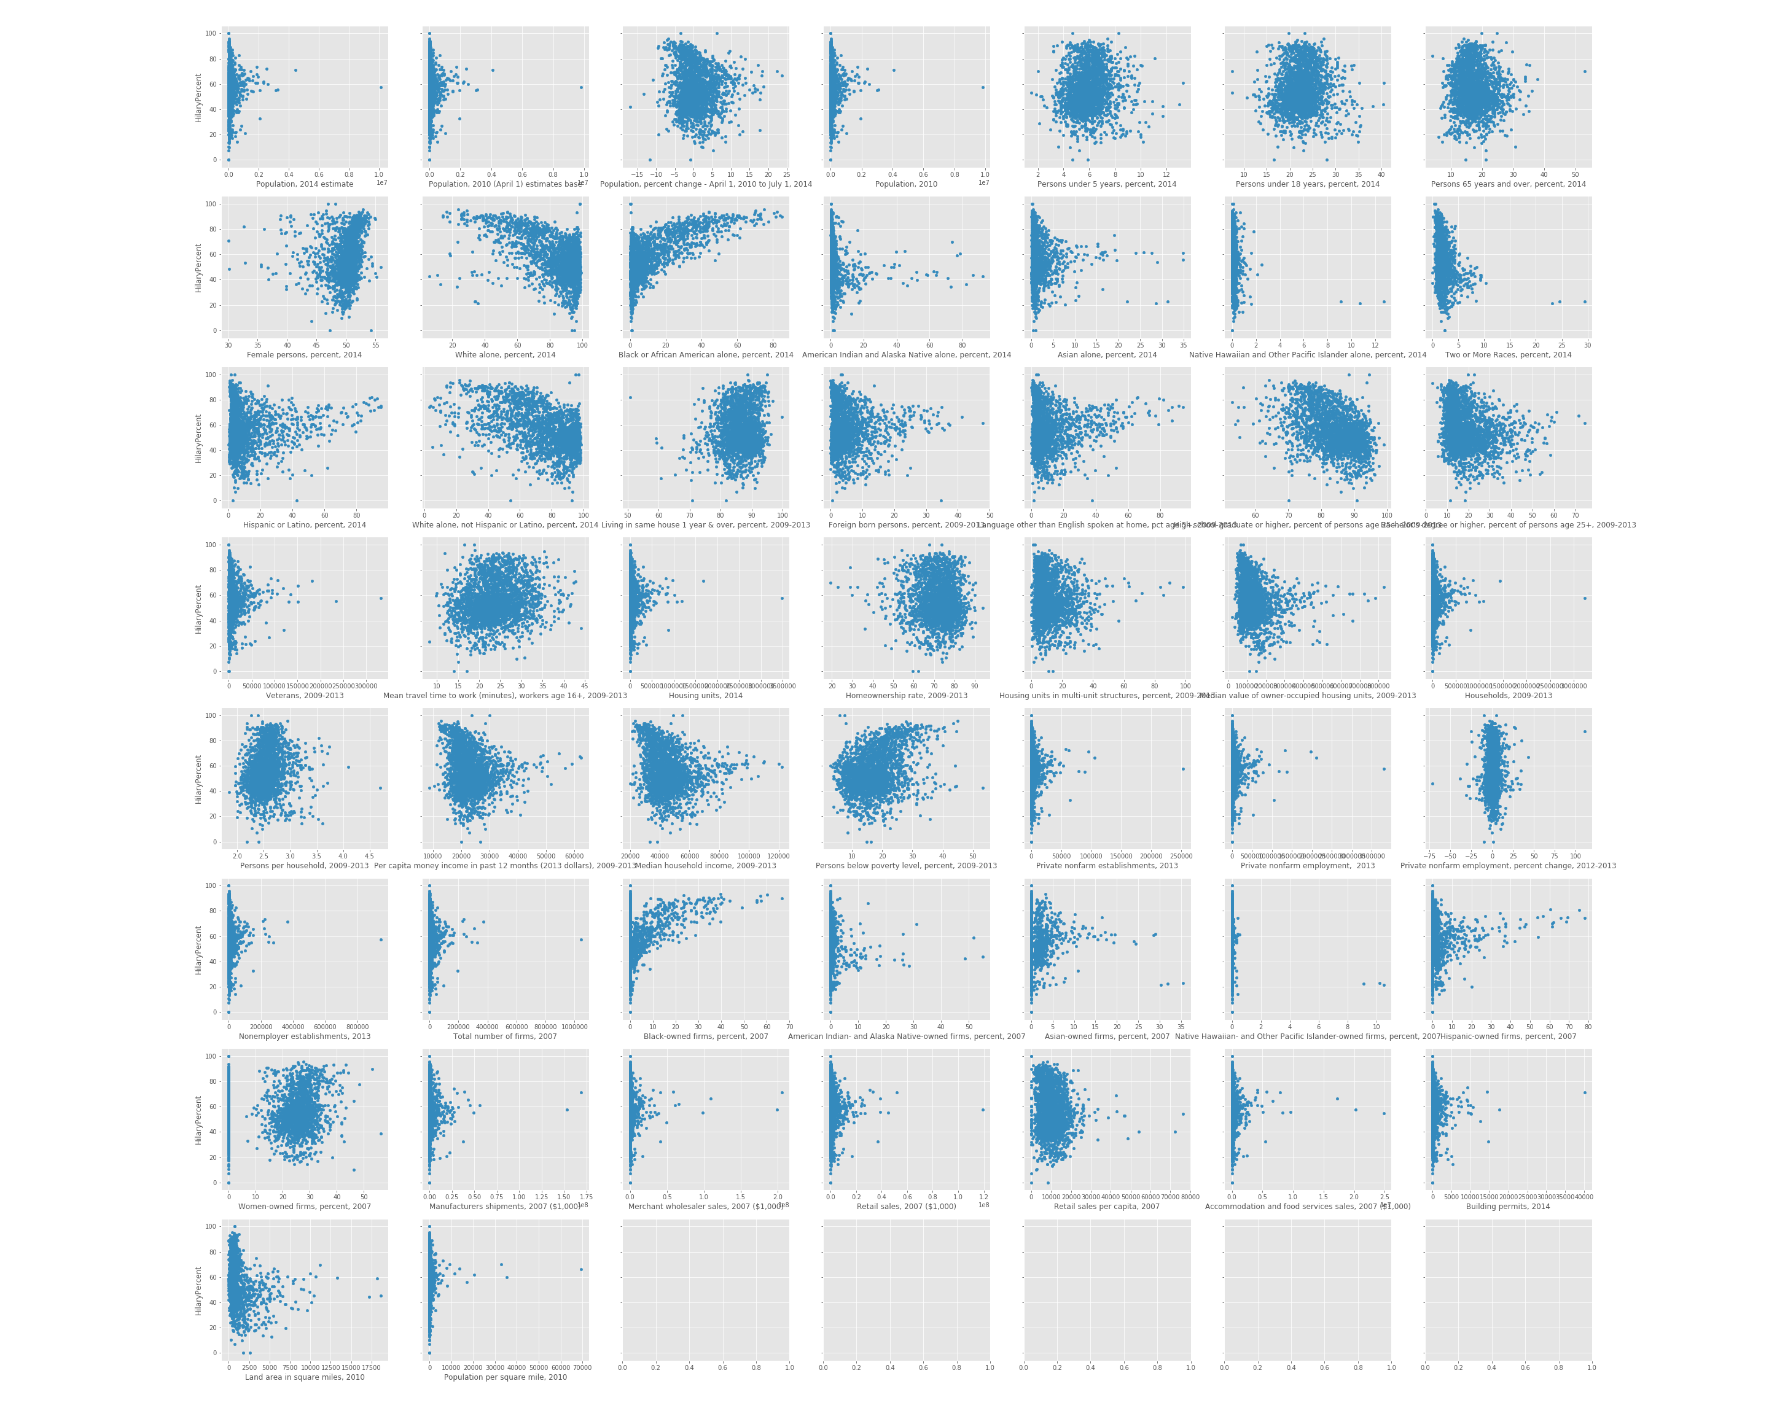
-Few have a linear relationship with respect to y and we will have to perform some transformation for our linear regression.
-Many plots are similar. For instance the 1st, 2nd and 4th plots are all plotting population against “HilaryPercent”. Those plots are similar due to the collinearity between each population variables.
This can be verified by building the scatter pairplots:

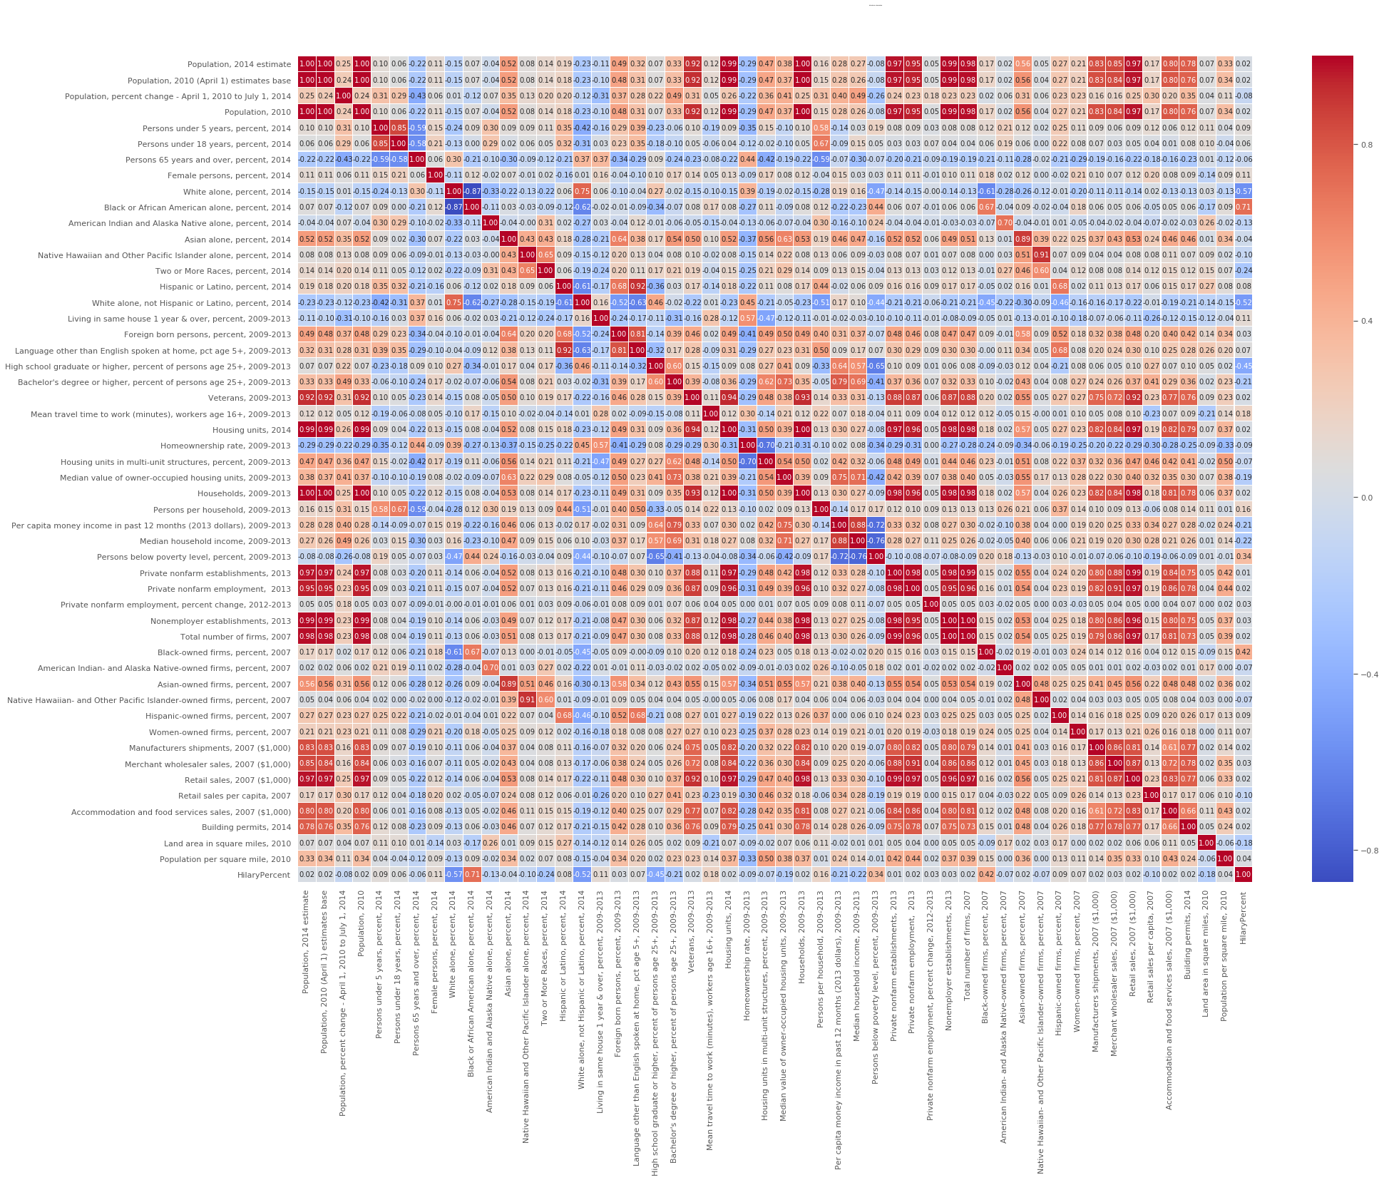

Land area in square miles, 2010
Female persons, percent, 2014

You are allowed to take power transformations of the original variables (square roots, logs, inverses, squares, etc), but you are NOT allowed to create interaction variables. Your model should include NO more than 5 predictors/covariates, but should explain as much variability as possible. After obtaining the model with aforementioned features, you are required to diagnose and analyze the model and provide meaningful interpretations. Please focus your attention on the interpretation of the model.
A strong analysis should include the interpretation of various coefficients, statistics, and plots associated with their model and the verification of any necessary assumptions.
Preconception
Without any knowledge: assumptions of trends: Trump voter :White blue collar/ old man with low degree of studies
Comments on data
a-No Nan, no categorical data (apart from state name)
b-Democrats and Republican do not have the same nber
Proposition
a- instead of high school or higher : high school= high school or higher - bachelor or higher bachelor bachelor or higher
b- % of black owned firms : correlated with percentage of black people ? we can also see the difference in percentage : bigger the difference bigger the inequalities
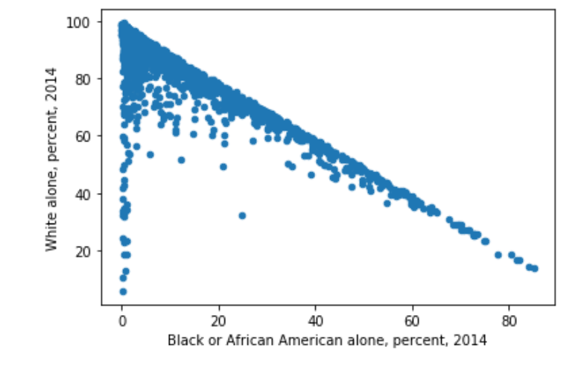
First features we can have
1- All data are more near 2014 than 2010
2-Just guess/ and plot seems not evenly distributed
4- plot
One of those first 2 : there are certainly some level of colinearity

(White) | R-squared: 0.325  Adj. R-squared: 0.325 | 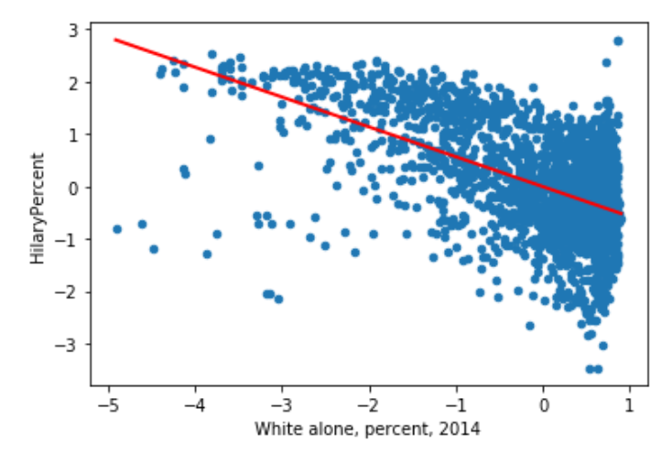
(Black) | R-squared: 0.502  Adj. R-squared: 0.502 | 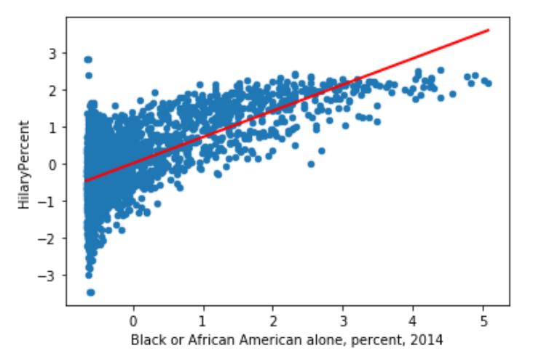
High school or higher | R=0.201 | 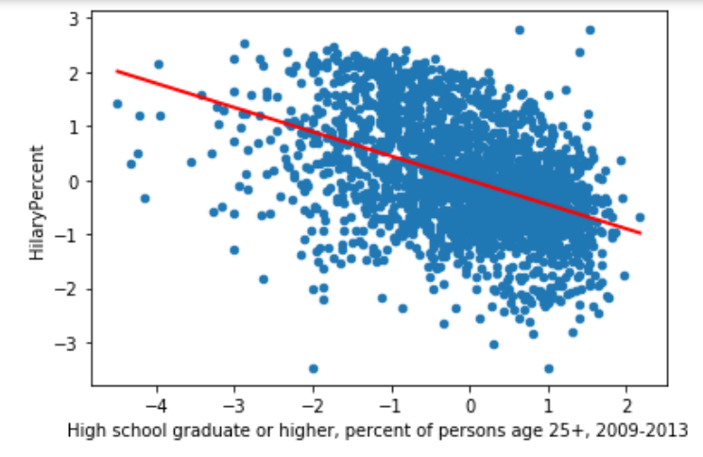
Person below poverty line | R=0.113 | 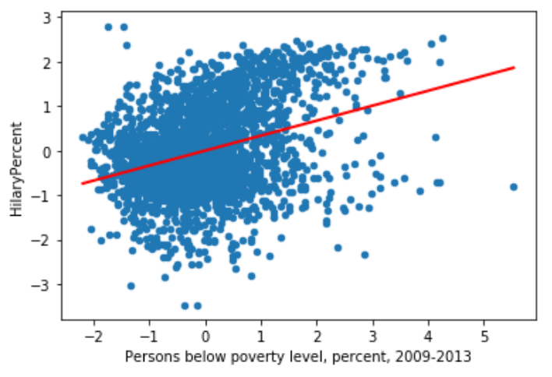
Black owned firm | 0.172 | 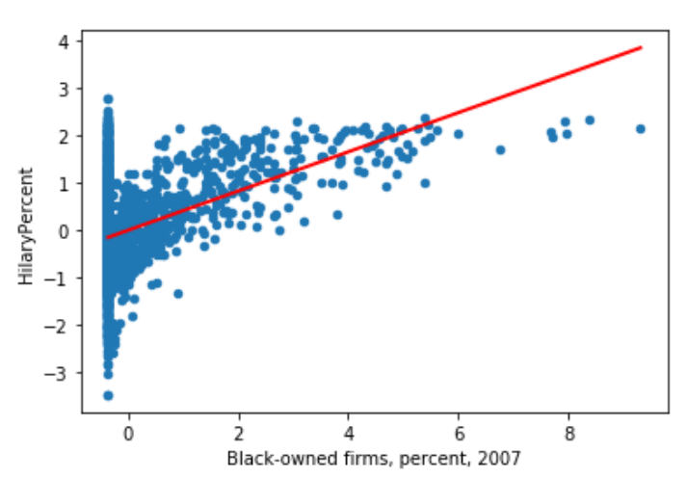

features = ['Population, 2014 estimate','Persons 65 years and over, percent, 2014'
'Female persons, percent, 2014','White alone, percent, 2014',"Bachelor's degree or higher, percent of persons age 25+, 2009-2013"]

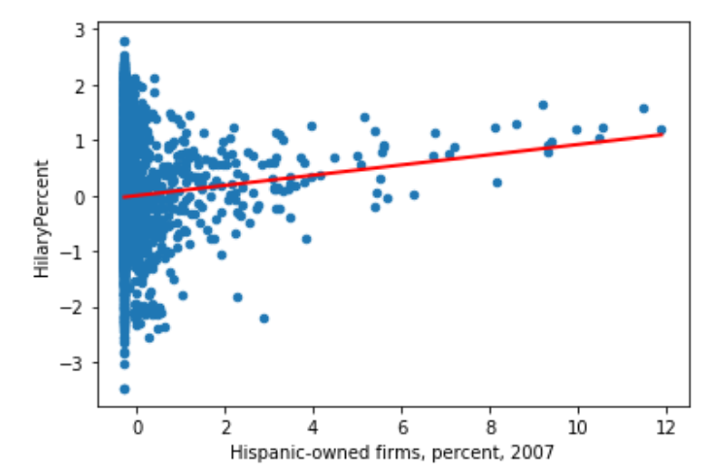
When high: pretty linear! Idea ?

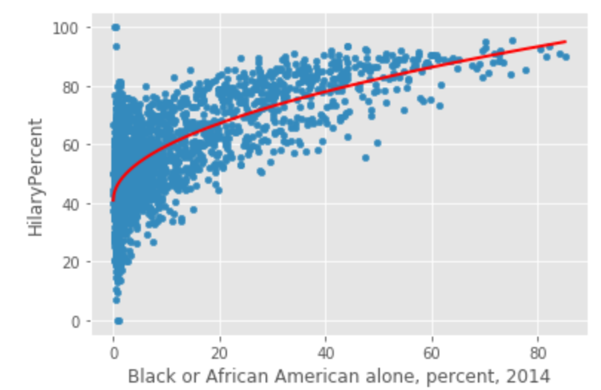

Normality check based on the residuals

Correlation check

(1) they’re pretty symmetrically distributed, tending to cluster towards the middle of the plot
(2) they’re clustered around the lower single digits of the y-axis (e.g., 0.5 or 1.5, not 30 or 150)
(3) in general there aren’t clear patterns

Y-axis Unbalanced
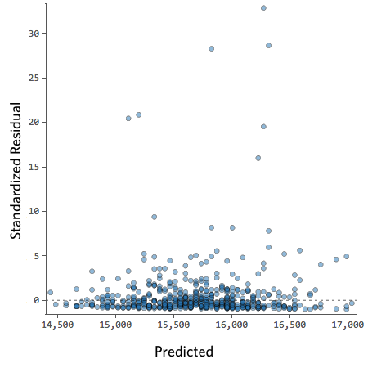

bell-shaped distribution

Implications
This almost always means your model can be made significantly more accurate. Most of the time you’ll find that the model was directionally correct but pretty inaccurate relative to an improved version. It’s not uncommon to fix an issue like this and consequently see the model’s r-squared jump from 0.2 to 0.5 (on a 0 to 1 scale).

How to fix
- The solution to this is almost always to transform your data, typically your response variable.
- It’s also possible that your model lacks a variable.

Heteroscedasticity

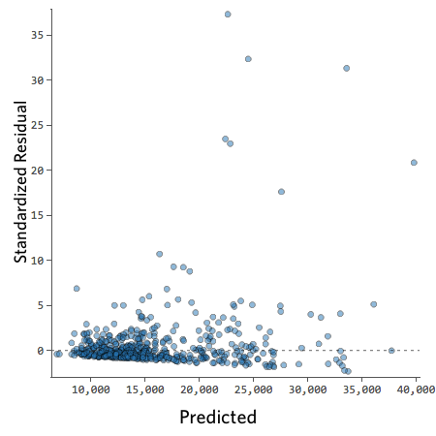
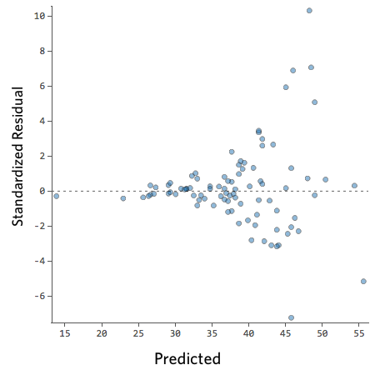

Residuals get larger as the prediction moves from small to large (or from large to small).

Implications
This doesn’t inherently create a problem, but it’s often an indicator that your model can be improved.
The only exception here is that if your sample size is less than 250, and you can’t fix the issue using the below, your p-values may be a bit be a bit higher or lower than they should be, so possibly a variable that is right on the border of significance may end up erroneously on the wrong side of that border. Your regression coefficients (the number of units Revenue changes when Temperature goes up one) will still be accurate, though.

How to Fix
- The most frequently successful solution is to transform a variable.
- Often heteroscedasticity indicates that a variable is missing.

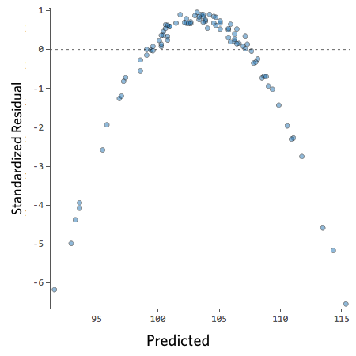
Nonlinear
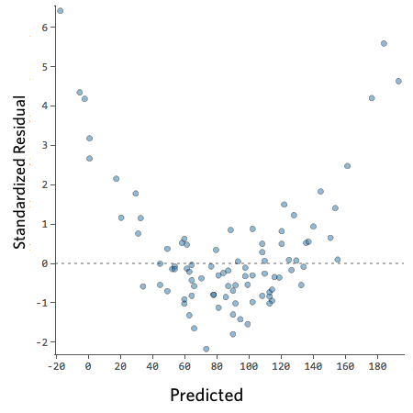

How to Fix
- Sometimes patterns like this indicate that a variable needs to be transformed.
- If the pattern is actually as clear as these examples, you probably need to create a nonlinear model (it’s not as hard as that sounds).
- Or, as always, it’s possible that the issue is a missing variable.

Outliers
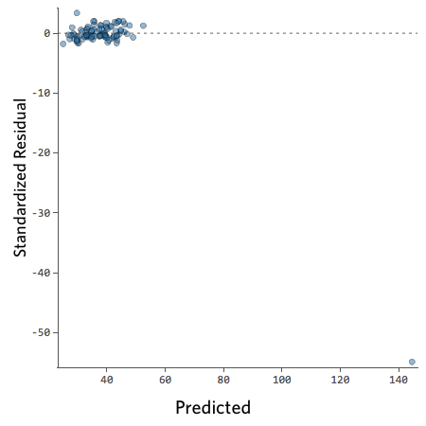

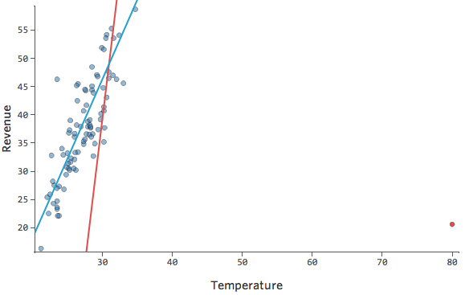
Implications
Statwing runs a type of regression that generally isn’t affected by output outliers (like the day with $160 revenue) but is affected by input outliers (like a Temperature in the 80s). In the worst case, your model can pivot to try to get closer to that point at the expense of being close to all the others, and end up being just entirely wrong, like this:
The blue line is probably what you’d want your model to look like, and the red line is the model you might see if you have that outlier out at Temperature 80.

How to fix
It’s possible that this is a measurement or data entry error, where the outlier is just wrong, in which case you should delete it.
- It’s possible that what appears to be just a couple outliers is in fact a power distribution. Consider transforming the variable if one of your variables has an asymmetric distribution (that is, it’s not remotely bell-shaped).
- If it is indeed a legitimate outlier, you should assess the impact of the outlier.

Large Y-axis Datapoints
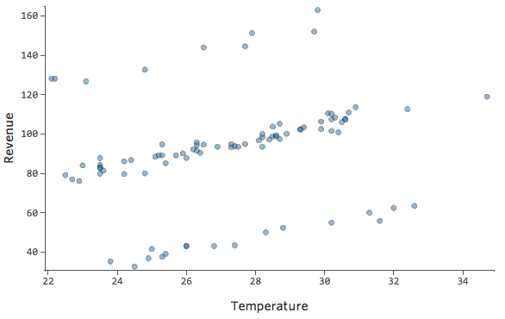

Implications
Your model isn’t worthless, but it’s definitely not as good as if you had all the variables you needed. You could still use it, and you might say something like “This model is pretty accurate most of the time, but then every once and a while it’s way off.” Is that useful? Probably, but that’s your decision, and it depends on what decisions you’re trying to make based on your model.

How to fix
- Even though this approach wouldn’t work in the specific example above, it’s almost always worth looking around to see if there’s an opportunity to usefully transform a variable.
- If that doesn’t work, though, you probably need to deal with your missing variable problem.

X-axis Unbalanced

How to fix
- The solution to this is almost always to transform your data, typically an explanatory variable. (Note that the example shown below will reference transforming your reponse variable, but the same process will be helpful here.)
- It’s also possible that your model lacks a variable.

